Class- I
Sub- Science

Answer the following questions? 3x3=9

1. What do we do in our dining room ?
Ans:

2. Why do we eat food ?

3. Name three food items each, which we get from plant and animals.

II. In which room will you keep the following things ? 3x1=3
1. Gas stove
2. Dining table
3. Bucket and mug

III. Tick (v) the correct option. 3x1=3
1. The meal eaten in the night is called

a. snaks b. breakfast c. dinner d. lunch

2. We need a to ________________________live in.

- house b. building c. room d. kutcha house

3. Kutcha houses are built in

- villages b. cities c. bigcities d. towns

IV. Write (p) for plant products and (A) for animal products. 4x1=4
- Tea powder 2. Grapes 3. Fish 4. Egg
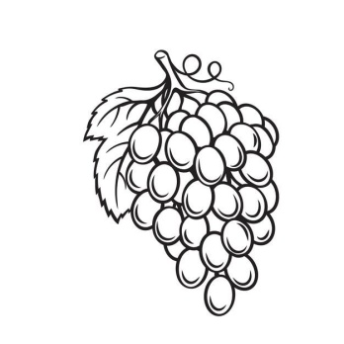


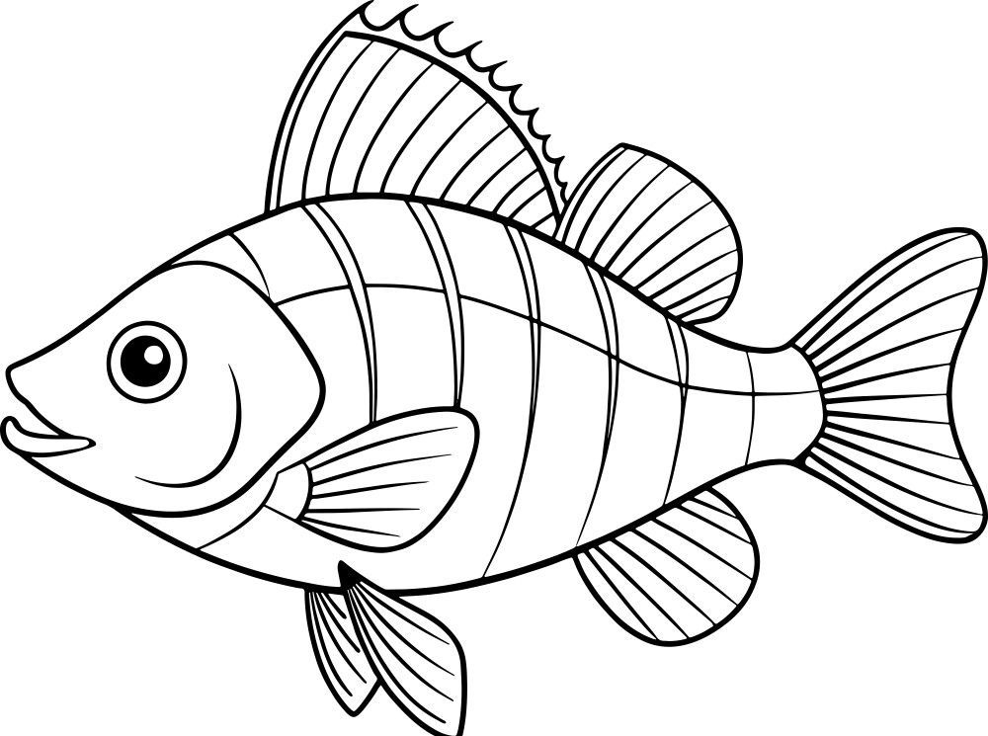

V. Name of some fruits and vegetables are hidden in this word grid . Find and colour them. 3x3=9

A | P | P | L | E | D
H | O | C | N | K | L
M | A | M | G | O | K
Y | D | E | N | G | Y
O | N | I | O | N | Y

VI. Make a house with the help of matchsticks as given and label the picture. 3X1=3

- Door

- window

- Roof

class- II
Sub - Science

- Answer the following questions. 3X3=9

1. Which types of clothes are worn in different season?
Ans:

2. What is a meal ? How many meals we take in a day ?
Ans:

3. Why do we need food ?
Ans:

- Fill in the blanks. 4X1=4
Igloo, caravan, rainy, Pucca

1. Permanent houses are also called ______________________ houses.
2. _______________________is a mobile house used by circus people.
3. _______________________is a Semi circular house made of ice blocks.
4. We carry umbrella to keep ourselves dry in _____________________________season.

- Prepare a menu for breakfast, lunch and dinner. 3X1=3

- BREAKFAST | 2. LUNCH | - DINNER

- Identify -the -type of house and write its name. 3x1=3

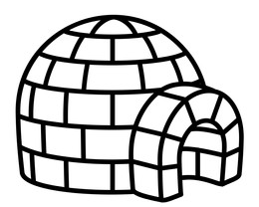 | 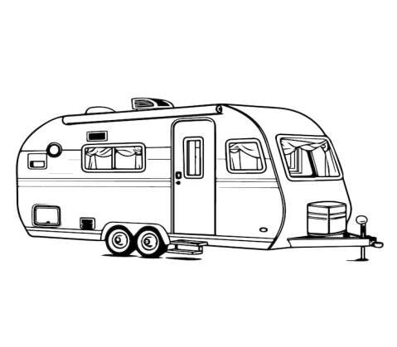 | 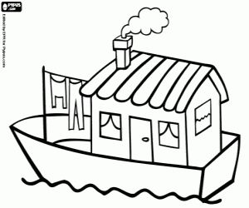

V. Match the following: 6x1=6
1. Body building food (a) milk
2. Energy giving food (b) fruits and vegetables
3. Food from plants (c) fish
4. Protective food (d) ladyfinger
5. Food from Animals (e) cereals
6. Complete food (f) eggs

class- III
(science)

I. Answer the following questions. 5X3=15m

1 What is our body made up of ?
2 How is blood useful to us ?
3 Why do we eat food ?
4 Differentiate between vegetarians and Non-vegetarians.
5 Why are pulses essential for children?

II Unscramble the jumbled body parts. 5X1=5m

1 BANRl _________________________________
2 GULNS ________________________________
3 NSNITETIE _______________________________
4 REHAT___________________________________
5 YNIKDE___________________________________

III Tick (√) -the correct option. 5X½= 2½m

1 We have ........ bones in our body.
a) 206 [ ] b) 602 [ ] c) 650 [ ] d) 500 [ ]

2 It is the building block of life.
a) organ [ ] b) cell [ ] c) tissue [ ] d) bone [ ]

3 It is -the master system of our body.
a) circulatory [ ] b) nervous [ ] c) skeletal [ ] d) muscular [ ]

4) It is not a plant product.
a) Vegetable [ ] b) cheese [ ] c) fruits [ ] d) oil [ ]

5 It is a cereal.
a) radish [ ] b) rice [ ] c) corn [ ] d) cardamom [ ]

IV Complete the flow chart. 5X½= 2½m

1. Food from Animals

CLASS IV (Science)
I Answer the following questions. 5 x 3 = 15 m

1) Write two basic properties of matter.
2) Define solute , solvent and solution.
3) What are CFL'S ?
4) How are shadows formed ?
5) Differentiate between transparent and opaque objects.

II Tick (v) the correct option : S5X½= 2½m

1. It is the universal solvent .
a) Milk [ ] b) oil [ ] c) petrol [ ] d) water [ ]

2. It is the smallest substance in a matter .
a) molecule [ ] b) atom [ ] c) solid [ ] d) liquid [ ]

3. light travels in a ............ line .
a) curved [ ] b) straight [ ] c) croocked [ ] d) None of these [ ]

4. It is not a source of light .
a) sun [ ] b) stars [ ] c) planet [ ] d) bulb [ ]

5. The molecules are very tightly packed in
a) solids [ ] b) liquids [ ] c) gases [ ] d) solutions [ ]

III Write T for true and F for false statements. 5 x V2 = 2V2

- Shadows are colourful . [ ]
- Shadows are short in the morning . [ ]
- Planets are natural sources of light. [ ]
- light travels in a straight line . [ ]
- Non - luminous objects do not give light [ ]

IV Name the Following. 5×1=5m

1 Two solids in our body ________________________ , ________________________
2 Two gases we breathe in and out ____________________ , ____________________
3 Two natural sources of light ________________________ , ______________________
4 Bouncing back of -the light _________________________ , ______________________
5 Two liquids we drink _______________________________ , ______________________

Class - V (science)

I. Answer the following question. 5 x 3 = 15 m

1. How are igneous rocks made ?
2. Why is pumice a light rock ?
3. How are liquids and solids different ?
4. What is an atom ?
5. How can the states of matter change ?

II Tick (v) the correct option. 4 x ½ = 2 m

1 Intermolecular forces are weakest in
a) gases [ ] b) solids [ ] c) liquids [ ] d) solutions[ ]

2) It is a liquid used as a fuel.
a) petrol [ ] b) kerosene [ ] c) diesel [ ] d) all of these [ ]

3 A liquid present in our body is
a) water [ ] b) plasma [ ] c) both a and b [ ] d) none of these [ ]

4) It is the smallest part of matter.
a) molecules [ ] b) atom [ ] c) solution [ ] d) substance [ ]

III. Give two examples of each of the following: 3 x 1 = 3 m
1 soluble liquids in water ________________________ , _______________________
2) Gases in the air ____________________________ , ________________________
3 Insoluble solutes in water ______________________ , ______________________

IV Encircle the correct option. 4 x ½ = 2 M

1) Igneous / sedimentary rocks are made due to the cooling of lava.
2) Minerals occur in the rocks in the form of fuels / ores

3) Pumice / Marble is used in the construction of buildings

4) Coal / petroleum is taken out from deep wells

V. Name the following 3 X 1 = 3M

1. A rock used as scrubber ___________________________________

2. A precious gemstone ________________________________________

3 Minerals from which metal can be extracted ______________________________

